It means whenever the first time instance of the class is requested, the external source will check whether it already has an instance of the class or not. If it does not have an instance, then it will create an instance and inject it into class. The second time, it will not create a new instance; instead, it will inject the old instance in new requested class.

When class A uses some functionality of class B, then it has said that class A has a dependency of class B

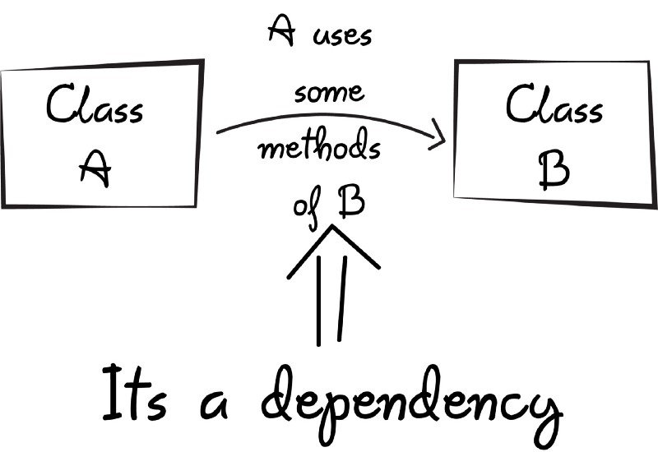

Before we can use methods of other classes, we first need to create the object of that class (i.e. class A needs to create an instance of class B)

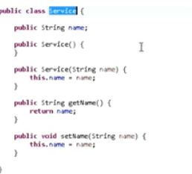

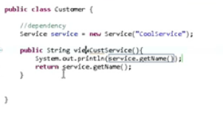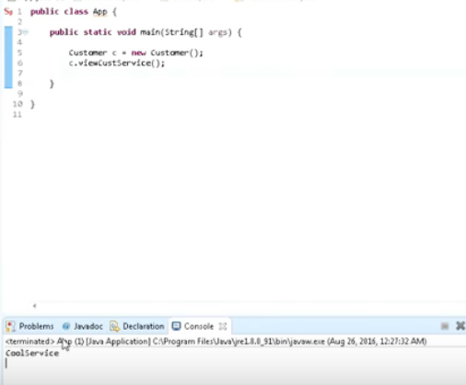

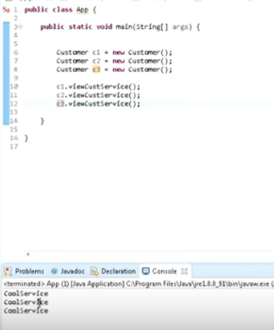

Getting 3 cool services because its dependency customer class dependency on service class

Here will use dependency injection

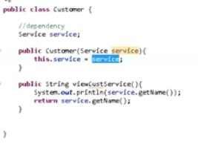

**Customer(Service service)**

**{**

**This.service = service**

**}**

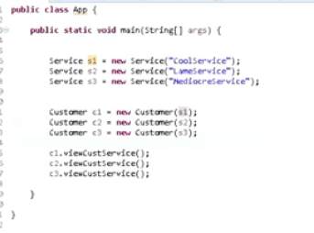

So when multiple methods wants to use same implementation we can go for create dependency injection

Purpose

1. To make loosely coupled
2. Make unit testing will be easier

